Impact 100 Grant Goals

- Foster change and have a long term positive impact
- Support programmatic or capital projects
- Create new, expand existing or replicate model programs that can improve and strengthen how an organization operates or positively change a community
- Demonstrate specific measureable outcomes and make a significant difference in the lives of people on the Greater Peninsula. Each application should be
Specific – audience, program and goals
Measurements – explain how they will evaluate program success and how they will know they met the stated goal
Achievable – must demonstrate the organization has the human and financial capitol to achieve the stated goals
Realistic – describe how the program is within the scope of the organization’s mission and can be reasonably accomplished
Transformative – show how the program will make a demonstrable difference in the community, the organization and/or the lives of the organization’s targeted population
Impact 100 Focus Area

Arts and Culture
Develop, cultivate and enrich the cultural and artistic community and/or the lives of individuals and families through the expressive arts or enhanced cultural awareness.

Education
Further the educational process, improve access to education for children and or adults, or prepare children and adults for 21st century careers through real world learning opportunities

Environment/Recreation/Conservation
Create recreational opportunities or restore, preserve, revitalize or enhance physical facilities or natural surroundings to create a sustainable community

Family
Strengthen and enhance the lives of children and families living in our community.

Health and Wellness
Improve the emotional, social, mental and/or physical well-being of people living in our community.
Impact 100 Grant Application

An online application will include the following and provide tools to upload required documents.
Describe the Impact 100 program/project.
Describe how funds will be used and the anticipated measureable outcomes.
Provide financial statements for current and last fiscal year, including audit report.
Provide agency budget information for current fiscal/calendar year and year-to-date status
Complete project budget and include next year pro forma project budget
Agency Governance
Signed “Terms of Agreement” form
Impact 100 Grant Eligibility

An organization must meet the following eligibility criteria for an Impact 100 grant,:
Be a nonprofit 501(c)(3) organization that serves residents of the Greater Peninsula (Gloucester, Hampton, James City County, Newport News, Poquoson, Williamsburg and York)
Have an operating budget of at least $250,000 (excluding in-kind)
Have been in operation at least 36 months
Provide copy of most recent financial audit OR 990
Expend 100% of the funds awarded by Impact 100 in the Greater Peninsula.
* Two or more nonprofits may collaborate on a transformative process and submit a joint application, but the lead applicant must satisfy the stated eligibility requirements.

Impact 100 Grant Restrictions

Faith based organizations are eligible to apply if the faith based organization is a part of collaborative grant application. Applications from religious organizations cannot be used to advance a faith-based program.
Applications from private foundations will not be accepted.
Funding to support general operating expenses, debt reduction or operational deficits, endowments or memorials, bridge or interim financing, partisan or political activities, events and or legal expenses will not be considered.
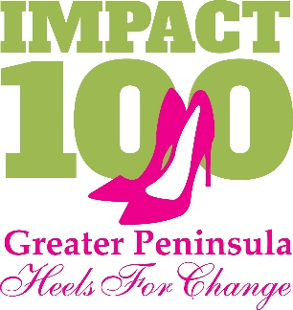
Organizations awarded Impact 1000 Grants may not apply for the following two years.

Annual Calendar

Grant Application Released April 6, 2017
BIG GIVE Grant Application due June 5, 2017
BIG GIVE Annual Event September 13, 2017

