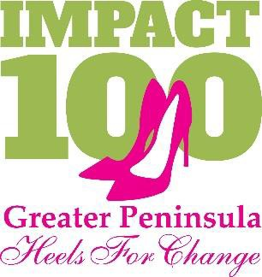
2018-2019 –Year 4: Membership Form

Name:______________________________________________________________ New Member
Email: ________________________________
Address: _________________________________________
City: State: __ _ Zip:_____________Telephone: ________________________________

MEMBERSHIP CONTRIBUTION – all membership contributions are due by May 31, 2019.
- I wish to become an Individual Member for $1,100 and have a vote.
- I wish to become a Circle Member and will join other members for a total of $1,100 and have one vote.
  - Circle Leader: Other Circle Members:
  - Please help me with a Circle and notify me of my Circle Leader.

PAYMENT OPTIONS – All contributions will be managed by our partner, the Peninsula Community Foundation.
Enclosed is my check for $ made payable to Peninsula Community Foundation, Memo: “Impact 100 Greater Peninsula”.
- I wish to pay with credit card. I understand that credit card payments will include an additional 2% to cover the credit card processing fee.
Charge my: ______Visa __MasterCard ______AMEX ______Discover
Card No: Exp. Date: Name on Card: Verification code: Signature:

  - I wish to make a Special gift in honor/memory of for $ .
  - I wish to make an additional donation to help with expenses for $ .
  - I wish to be a Friend of Impact 100 Greater Peninsula and make a donation for $ .

PARTICIPATION
As a voting member, I am interested in actively participating as a volunteer on one or more of the below committees.
    - Grants ☐Membership ☐Newsletter ☐Social Media ☐Events

RECOGNITION
- I grant permission to Impact 100 Greater Peninsula and the Peninsula Community Foundation to use my name and photo on electronic and printed donor lists, website and other promotional materials.
- I would like my name to appear as:
- I wish to remain anonymous for purposes of public recognition.
- I agree that my email will be used as the primary means of communication only for Impact 100 volunteers and Peninsula Community Foundation staff.

Signature: Date:

Please return form by March 31st. Payment is due by May 31st.

The Peninsula Community Foundation ATTENTION: IMPACT 100 Greater Peninsula 48 Queens Way, Hampton, Virginia 23669
For additional information contact Peninsula Community Foundation at 757-327-0862 or email jbrambley@pcfvirginia.org

Impact 100 Greater Peninsula is a component fund of the Peninsula Community Foundation; a non-profit organization exempt from federal taxes under IRS Code 501(c)(3). Contributions are tax deductible.

