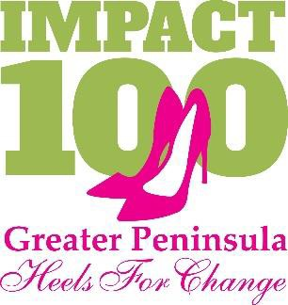
2019-2020 –Year 5: Membership Form

Name: ______________________________________________________________ New Member
Email:___________________________________________________ Phone:__________________________________
Address: _________________________________________

MEMBERSHIP CONTRIBUTION – all membership contributions are due by June 1, 2020.
- Individual Member $1,100
Circle Member $550 I am the Circle Leader
$367 Circle Member
$275 Help me find a Circle
I am interested in hosting a Little Join
PAYMENT OPTIONS – All contributions will be managed by our partner, the Peninsula Community Foundation.

Check Enclosed Will mail in a check

Make payable to Peninsula Community Foundation, Memo line “Impact 100”

- I wish to pay with credit card. I understand that credit card payments will include an additional 2% to cover the credit card processing fee.
Charge my: ______Visa __MasterCard ______AMEX ______Discover
Card No: Exp. Date: Name on Card: Verification code: Signature:

  - Please contact me about making monthly payments
  - Please contact me about making a donation other than the above options

Volunteer Opportunities
Let us know if you are interested in learning more about being more involved!

    - Grants ☐Membership ☐Publicity ☐Social Media ☐Events

RECOGNITION
- I grant permission to Impact 100 Greater Peninsula and the Peninsula Community Foundation to use my name and photo on electronic and printed donor lists, website and other promotional materials.
- I would like my name to appear as:
- I wish to remain anonymous for purposes of public recognition.
- I agree that my email will be used as the primary means of communication only for Impact 100 volunteers and Peninsula Community Foundation staff.

Signature: Date:

Please return form by March 31st. Payment is due by June 1st.

The Peninsula Community Foundation ATTENTION: IMPACT 100 Greater Peninsula 48 Queens Way, Hampton, Virginia 23669
For additional information contact Peninsula Community Foundation at 757-327-0862 or email jbrambley@pcfvirginia.org

Impact 100 Greater Peninsula is a component fund of the Peninsula Community Foundation; a non-profit organization exempt from federal taxes under IRS Code 501(c)(3). Contributions are tax deductible.

